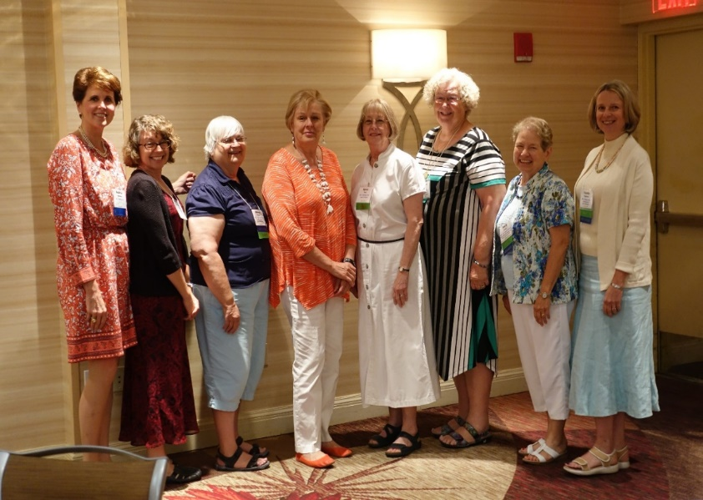
Melissa Johnsen, Colorado e-Network Branch and National Board Member, and newly elected AAUW NM Officers
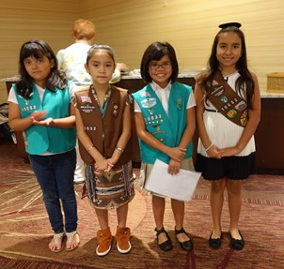Girl Scouts present colors

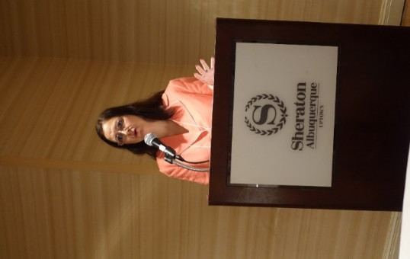Nina Martinez represents the Albuquerque Mayor’s Office
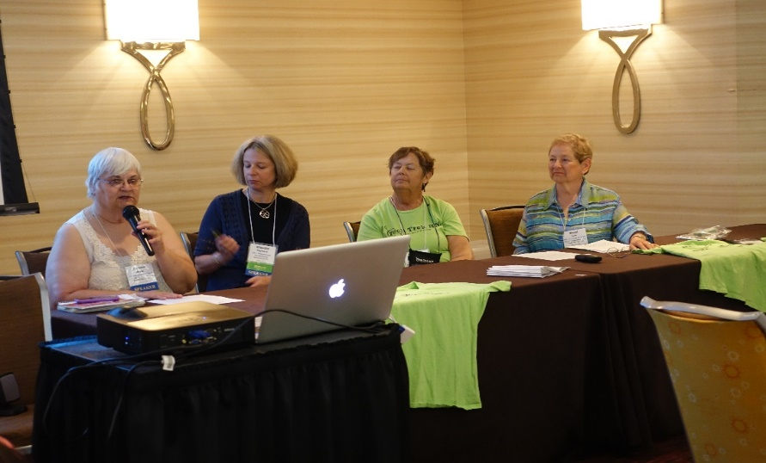
Tech Trek NM Panel, Helena Whyte, Claudia Poglitsch, Mary Rita Chapman, Karyl Lyne
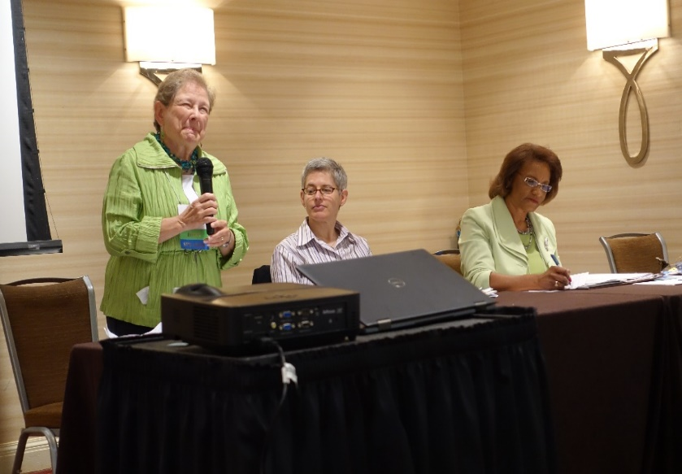
Fair Pay for Women Panel, Karyl Lyne, Jamie Philips, Pamelya Herndon

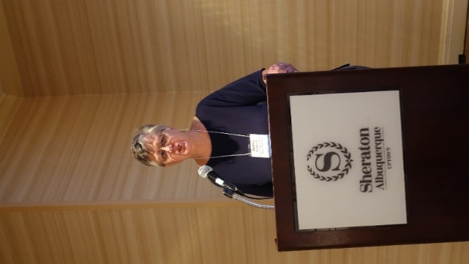CO strategic planning by Marilyn Zimmerman and AZ Happenings by Ana Nygren and Michelle Higgins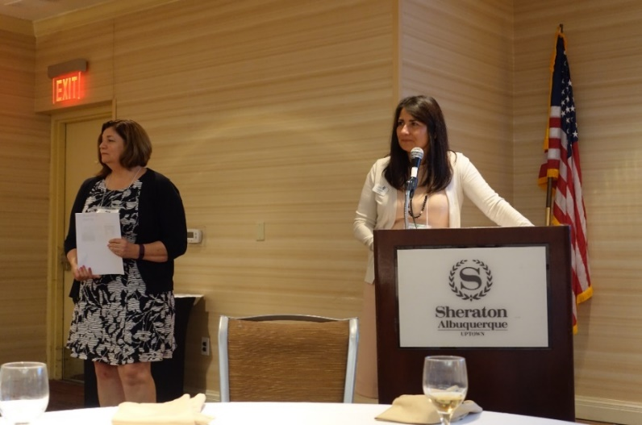
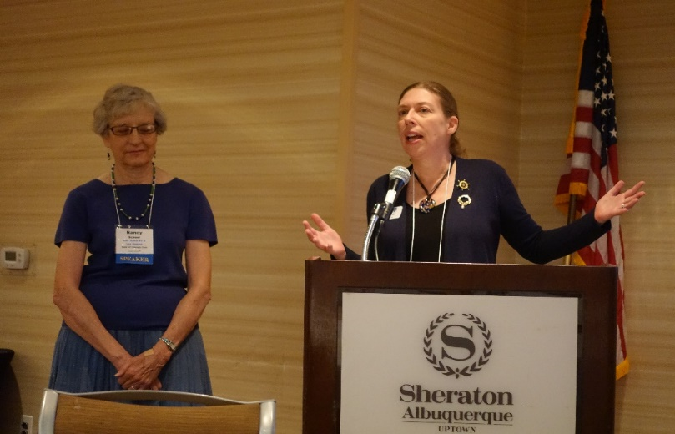
UN Commission on the Status of Women by Amy Blackwell, CO President and Nancy Scheer, NM International Interest Chair
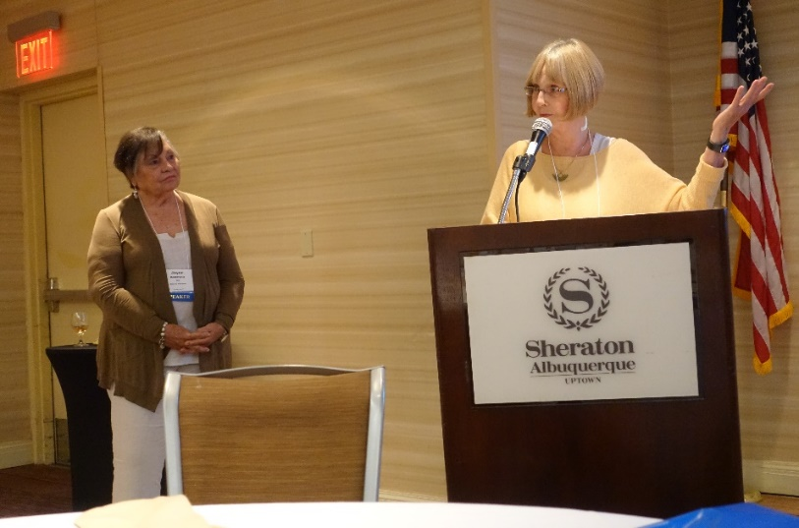NV presentation, Why a Satellite Branch by Joyce Destefanis and Byllie Andrews
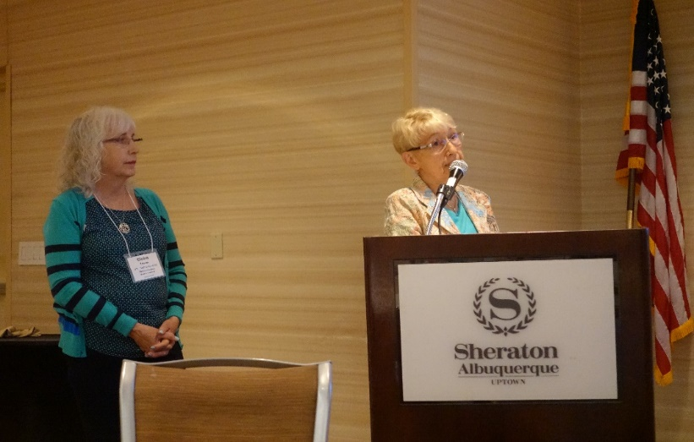UT Putting Art Back Into STEM (STEAM) by Claire Turner, Gloria Powell and Kathy Horvatl
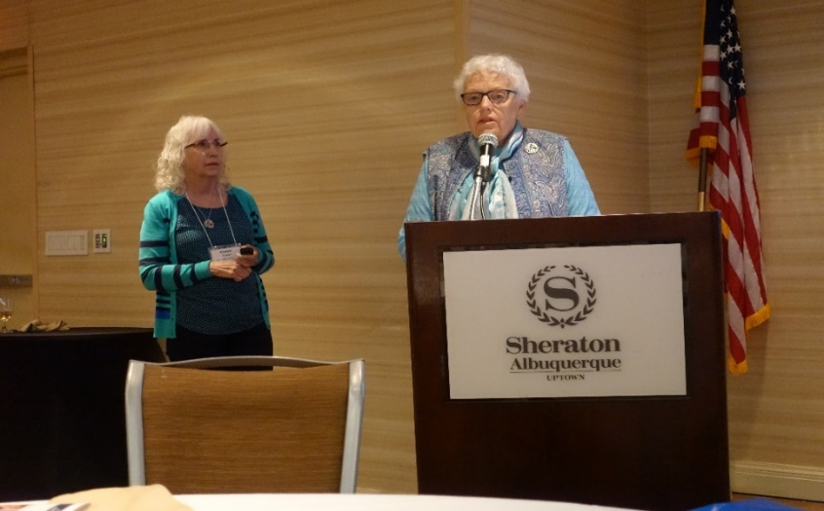
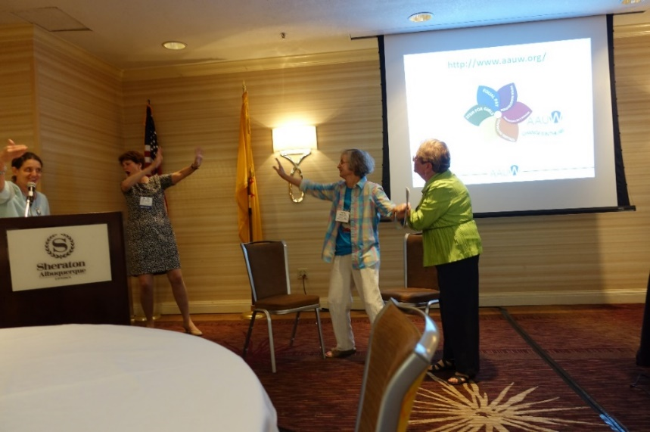
Role Playing with Katherine Hill, Researcher, Barriers and Bias
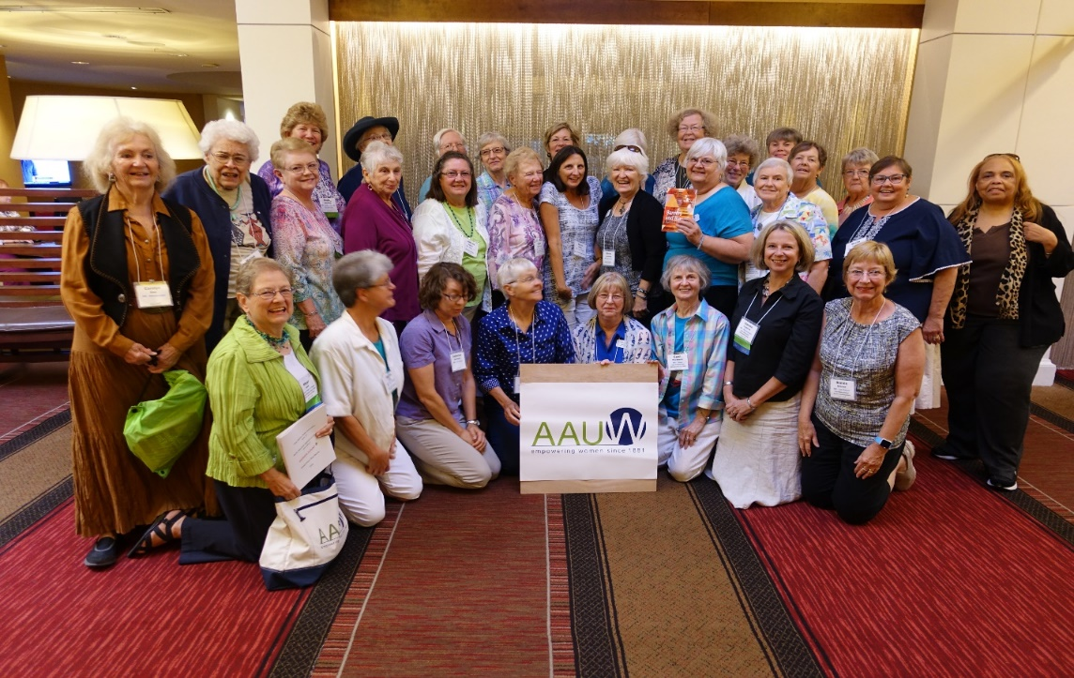
New Mexico Delegation to Rocky Mountain Regional Conference
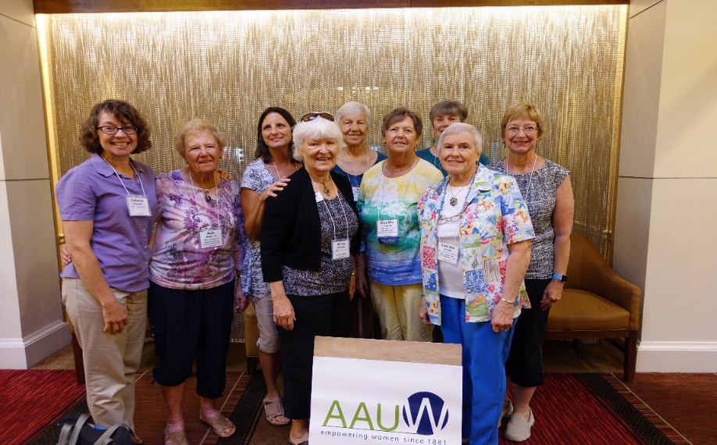
Las Cruces Delegation to Rocky Mountain Regional Conference
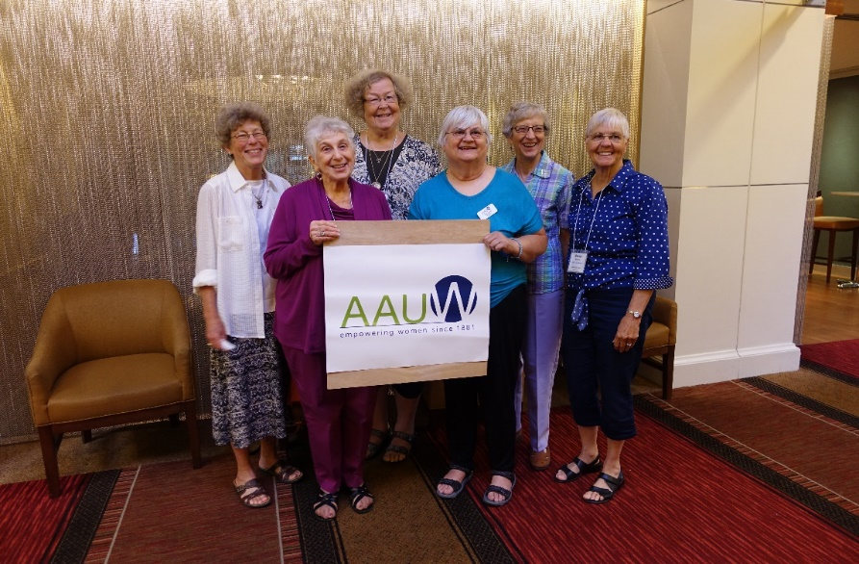
Los Alamos Delegation to Rocky Mountain Regional Conference
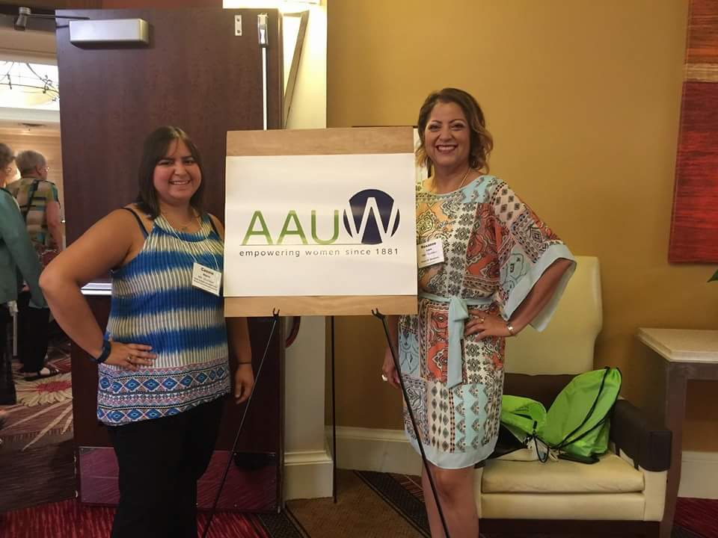
Carlsbad Delegation to Rocky Mountain Regional Conference
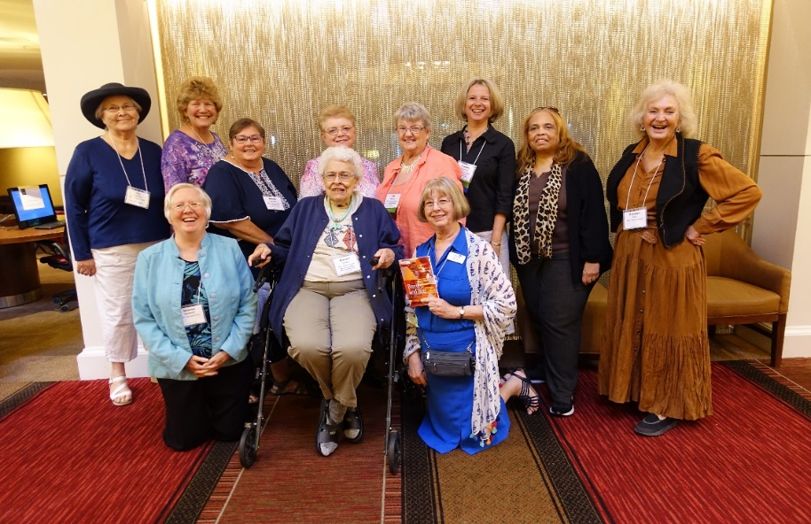
Albuquerque Delegation to Rocky Mountain Regional Conference
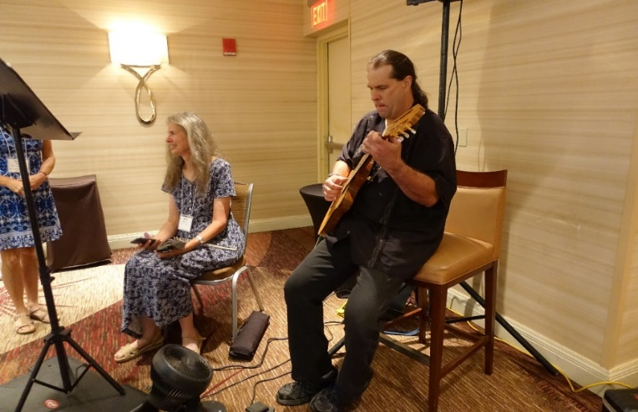
Music provided by Edith and Billy Isidoro

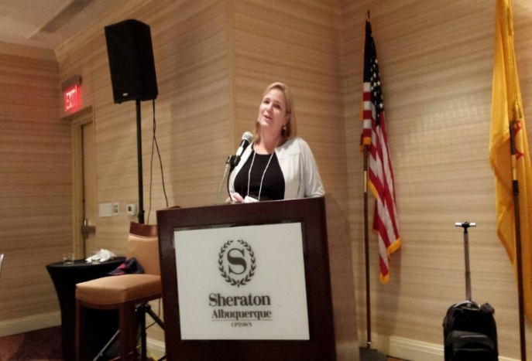
Susan Burk, LAF Speaker, military assault attorney
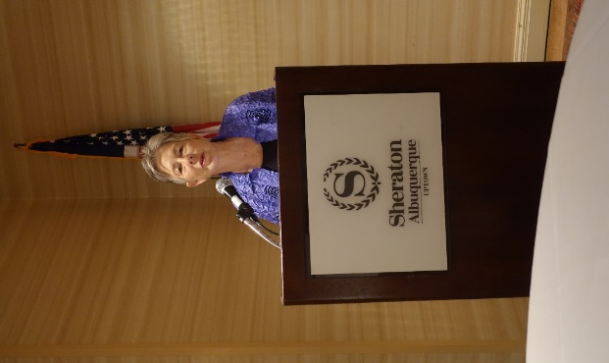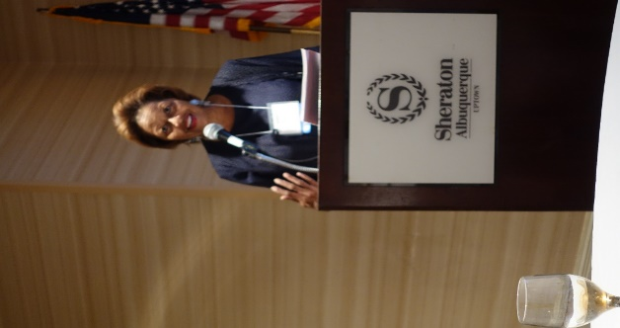
Martha Burke, Pay Equity Speaker Julia Brown, Diversity Speaker
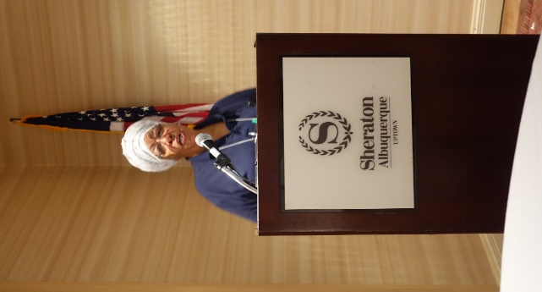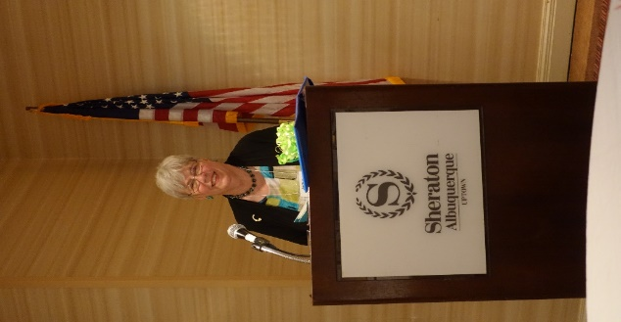
RC Johnson, WY Jackie Littleton, TX, Estate Planning

